Mutchumari Chandrsekhar Reddy
AP25110010976
1. Greedy Approach: Implementation of Huffman code
Program:
#include<stdio.h>
#include<stdlib.h>
struct Node{
int data;
char ch;
struct Node *left,*right;
};
struct Node* newNode(int data,char ch){
struct Node* node=(struct Node*)malloc(sizeof(struct Node));
node->data=data;
node->ch=ch;
node->left=node->right=NULL;
return node;
}
void sort(struct Node* a[],int n){
int i,j;
struct Node* temp;
for(i=0;i<n-1;i++)
for(j=0;j<n-i-1;j++)
if(a[j]->data>a[j+1]->data){
temp=a[j];
a[j]=a[j+1];
a[j+1]=temp;
}
}
void printCodes(struct Node* root,int code[],int top){
int i;
if(root->left){
code[top]=0;
printCodes(root->left,code,top+1);
}
if(root->right){
code[top]=1;
printCodes(root->right,code,top+1);
}
if(!root->left&&!root->right){
printf("%c: ",root->ch);
for(i=0;i<top;i++)
printf("%d",code[i]);
printf("\n");
}
}
int main(){
int n,i,code[100];
char ch;
struct Node* a[100];
printf("Enter number of characters: ");
scanf("%d",&n);
printf("Enter character and frequency:\n");
for(i=0;i<n;i++){
scanf(" %c%d",&ch,&code[i]);
a[i]=newNode(code[i],ch);
}
while(n>1){
sort(a,n);
struct Node* left=a[0];
struct Node* right=a[1];
struct Node* parent=newNode(left->data+right->data,'$');
parent->left=left;
parent->right=right;
a[0]=parent;
for(i=1;i<n-1;i++)
a[i]=a[i+1];
n--;
}
printf("Huffman Codes:\n");
printCodes(a[0],code,0);
return 0;
}

Terminal Process:
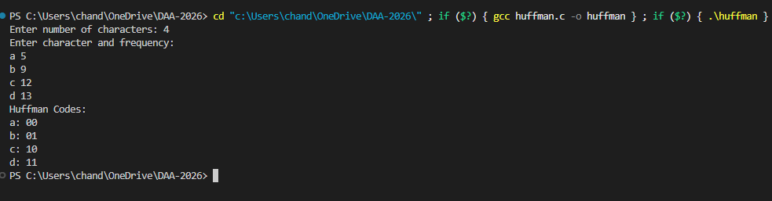

- Assume that the numbers given below represent counts of letters in the hundreds from a file (similar to the CLRS example). For example, in the file there will be exactly 20
- 100 occurrences of the letter ‘a’ , 11*100 occurrence of the letter ‘c’, etc. a: 20, c:11, d:2, e: 10, o:15, m:8, s:10, t:22, u: 2 a) What is an optimal Huffman code based on the following set of frequencies?
- Draw the tree. Show your work at every step.
- Fill in the table on the right the Huffman encoding for each letter.
- We encode the file using the Huffman codes produced above. How much memory will the file require with this encoding?
Handwritten Solution:
